Experiment Title: 3

# Student Name:Rahul Maurya UID:20BCS7260

**Branch:** BE CSE **Section/Group:**

# Semester: 4th Date of Performance:

**Subject Name:** Microprocessor And Interfacing Lab

# Subject Code:

1. **Aim/Overview of the practical:**
   * Subtraction of two 8 bit numbers along with considering borrow
2. **Task to be done:**

Subtraction of two 8 bit numbers along with considering borrow

1. **Apparatus/Simulator used (For applied/experimental sciences/materials based labs):**
2. Jubin Application
3. 8085 Simulator
4. JDK
5. **Algorithm/Flowchart (For programming based labs):**
   1. Load the H-L pair with the address of first memory location.
   2. Move the content of H-L to accumulator.
   3. Increment H-L pair to next memory location.
   4. Load the register B with the memory location of second data.
   5. Initialize register C with 00H. this will store the borrow (if any).
   6. Subtract the content of accumulator with the content of register B and the result will be stored in accumulator automatically.
   7. If carry flag is set then increment register C.
   8. Increment H-L pair.
   9. Move result from accumulator to memory location 3002H.
   10. Increment H-L pair.
   11. Move borrow from register C to memory location 3003H.

.

1. **Description/ Code:**

#BEGIN 000H MVI A,32H MVI B,43H SUB B

HLT

1. **Result/Output/Writing Summary:**

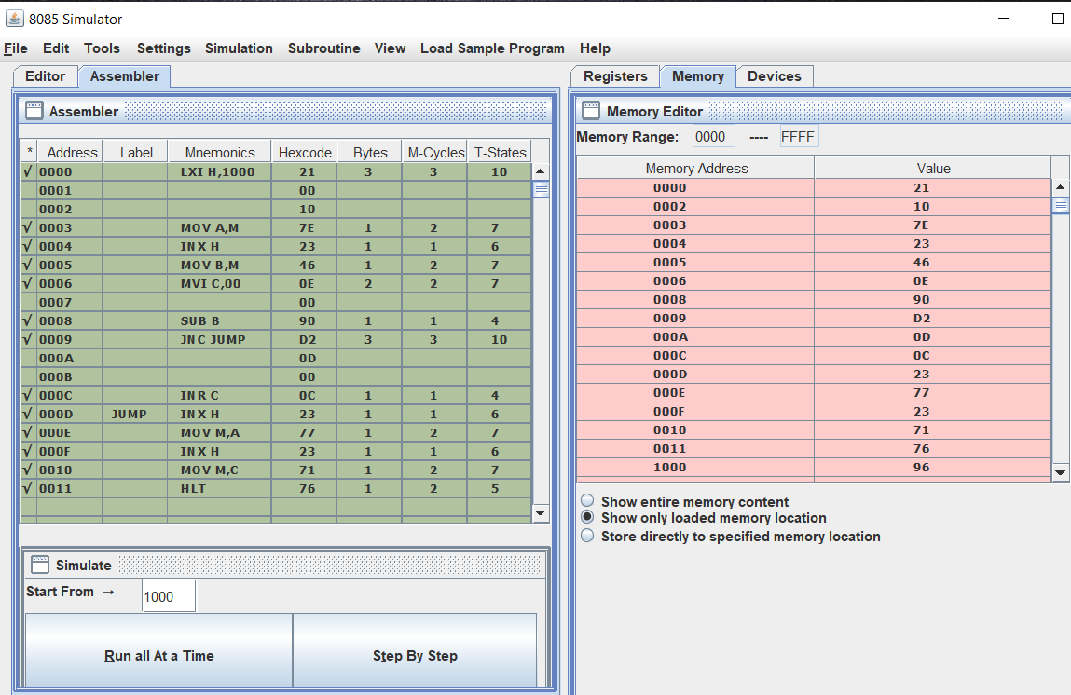

* 1. **Aim/Overview of the practical:**
* Subtraction of two 16 bit numbers along with considering borrow
  1. **Task to be done:**

Subtraction of two 16 bit numbers along with considering borrow

* 1. **Apparatus/Simulator used :**
     1. Jubin Application
     2. 8085 Simulator
     3. JDK
     4. **Algorithm/Flowchart:**
        1. Load 0000H into CX register (for borrow)
        2. Load the data into AX(accumulator) from memory 3000
        3. Load the data into BX register from memory 3002
        4. Subtract BX with Accumulator AX
        5. Jump if no borrow
        6. Increment CX by 1
        7. Move data from AX(accumulator) to memory 3004
        8. Move data from CX register to memory 3006
        9. Stop

# Description/ Code:

# BEGIN 0000

LHLD 3050 XCHG LHLD 3052 MOV A,E SUB L MOV L,A MOV A,D

SBB H MOV H,A SHLD 3054 HLT

# ORG 3050H

# DB 86H,94H,B0H,A7H

* + 1. **Result/Output/Writing Summary:**

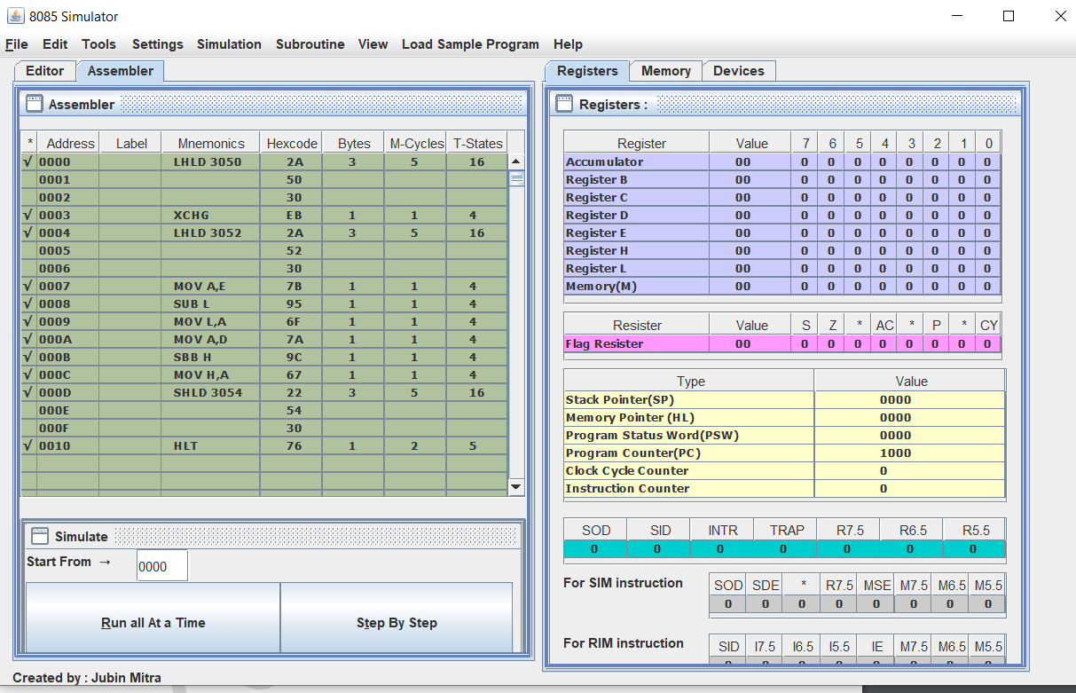

**Learning outcomes (What I have learnt):**

1. Working of microprocessors.
2. Learn how to do mathematical operations in microprocessors.
3. Learn about 8085 simulator.
4. Operations of 8 bit numbers.
5. Learn about the different instructions that are needed to be given to the memory to perform some tasks.

**Evaluation Grid (To be created as per the SOP and Assessment guidelines by the faculty):**

|  |  |  |  |
| --- | --- | --- | --- |
| Sr. No. | Parameters | Marks Obtained | Maximum Marks |
| 1. |  |  |  |
| 2. |  |  |  |
| 3. |  |  |  |
|  |  |  |  |